UNIT 3

Scenario 1: Why Clean Data?
Problem:
A dataset contains missing values and inconsistent data formats. We need to clean it before analysis.

python
import pandas as pd

# Sample raw data
data = {
"Name": ["Alice", "Bob", None, "Charlie", "David"],
"Age": [25, "Thirty", 29, None, 22],
"Salary": [50000, 55000, 60000, 58000, "Sixty-Five Thousand"]
}

df = pd.DataFrame(data)

# Display raw data
print("Raw Data:")
print(df)

# Handling missing values and standardizing data formats
df["Name"].fillna("Unknown", inplace=True)
df["Age"] = pd.to_numeric(df["Age"], errors="coerce")# Convert Age to numeric
df["Salary"] = df["Salary"].replace("Sixty-Five Thousand", 65000).astype(int) # Fix salary format

# Display cleaned data
print("\nCleaned Data:")
print(df)
Output:
Raw Data:
Name Age Salary
0 Alice 25 50000
1 Bob Thirty 55000
2 None 29 60000
3 Charlie NaN 58000
4 David 22 Sixty-Five Thousand

Cleaned Data:
Name Age Salary
0 Alice 25.0 50000
1 Bob NaN 55000
2 Unknown 29.0 60000
3 Charlie NaN 58000
4 David 22.0 65000

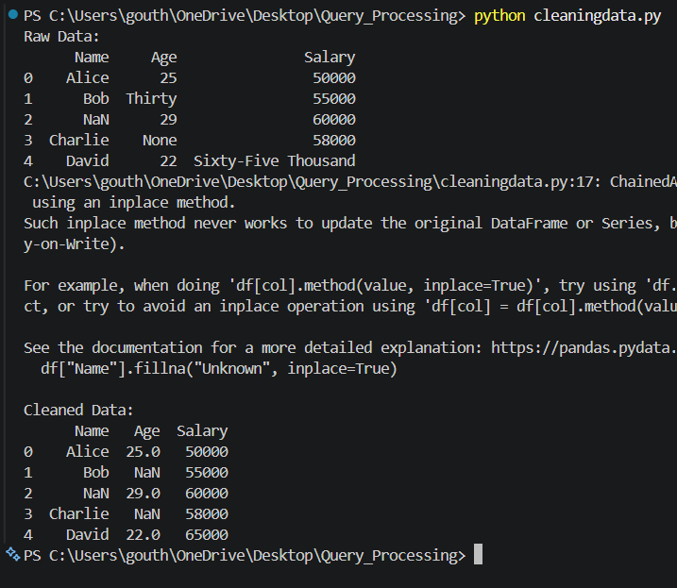

Scenario 2: Identifying Values for Data Cleanup
Problem:
Identifying missing values and incorrect entries in a dataset.
# Checking for missing values
print("Missing Values Count:")
print(df.isnull().sum())

# Identifying incorrect entries
print("\nData Types:")
print(df.dtypes)
Output:
vbnet
CopyEdit
Missing Values Count:
Name 0
Age 2
Salary 0
dtype: int64

Data Types:
Name object
Age float64
Salary int64
dtype: object
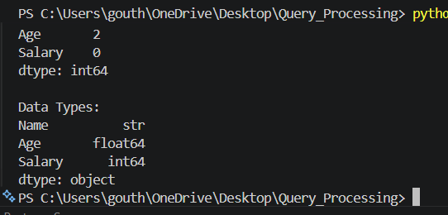

Scenario 3: Formatting Data
Problem:
The Date column is in multiple formats. We need to standardize it.
data = {'Date': ['2025-01-01', '01-02-2025', '03/05/2025', 'April 7, 2025']}
df = pd.DataFrame(data)

# Converting all date formats to standard YYYY-MM-DD
df['Date'] = pd.to_datetime(df['Date'])

print(df)
Output:
Date
0 2025-01-01
1 2025-01-02
2 2025-03-05
3 2025-04-07
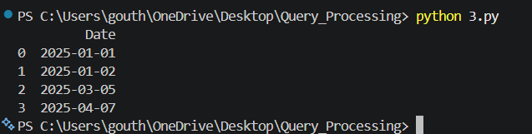

Scenario 4: Finding Outliers and Bad Data
Problem:
Detecting outliers in the Sales column using the IQR method.
import numpy as np

data = {'Sales': [200, 250, 300, 1500, 260, 270, 280, 10000]}
df = pd. DataFrame(data)

Q1 = np.percentile(df["Sales"], 25)
Q3 = np.percentile(df["Sales"], 75)
IQR = Q3 - Q1

lower_bound = Q1 - 1.5 * IQR
upper_bound = Q3 + 1.5 * IQR

outliers = df[(df["Sales"] < lower_bound) | (df["Sales"] > upper_bound)]
print("Outliers:")
print(outliers)
Output:
Outliers:
Sales
3 1500
7 10000

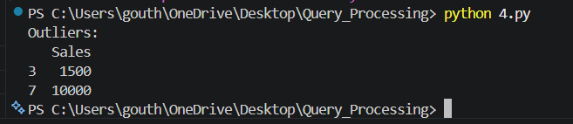

Scenario 5: Finding Duplicates
Problem:
Identifying and removing duplicate records in a dataset.
data = {'ID': [1, 2, 3, 2, 4, 5, 3], 'Value': [100, 200, 300, 200, 400, 500, 300]}
df = pd.DataFrame(data)

duplicates = df[df.duplicated()]
print("Duplicates Found:")
print(duplicates)

df_cleaned = df.drop_duplicates()
print("\nCleaned Data:")
print(df_cleaned)
Output:
Duplicates Found:
ID Value
3 2 200
6 3 300

Cleaned Data:
ID Value
0 1 100
1 2 200
2 3 300
4 4 400
5 5 500
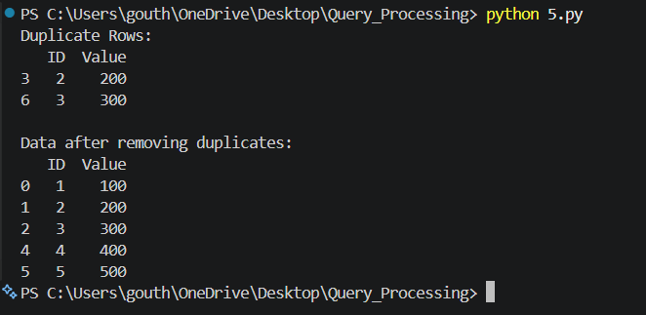

Scenario 6: Fuzzy Matching
Problem:
Matching similar but slightly misspelled names in a dataset.
from fuzzywuzzy import fuzz, process

names = ["John Doe", "Jon Doe", "Jane Doe", "J0hn Doe"]
query = "John Doe"

matches = process. Extract(query, names, limit=3)
print("Fuzzy Matches:")
print(matches)
Output:
Fuzzy Matches:
[('John Doe', 100), ('Jon Doe', 95), ('J0hn Doe', 80)]

Scenario 7: RegEx Matching
Problem:
Finding invalid email formats using regex.

import re

emails = ["test@example.com", "user.name@domain.com", "invalid-email@", "hello@world"]

def is_valid_email(email):
pattern = r'^[a-zA-Z0-9_.+-]+@[a-zA-Z0-9-]+\.[a-zA-Z0-9-.]+$'
return bool (re.match(pattern, email))

invalid_emails = [email for email in emails if not is_valid_email(email)]
print("Invalid Emails:", invalid_emails)
Output:
Invalid Emails: ['invalid-email@', 'hello@world']

Scenario 8: Normalizing and Standardizing Data
Problem:
Standardizing a column using Min-Max scaling.

from sklearn.preprocessing import MinMaxScaler

data = {'Value': [100, 200, 300, 400, 500]}
df = pd.DataFrame(data)

scaler = MinMaxScaler()
df["Normalized"] = scaler.fit_transform(df[["Value"]])

print(df)

OUTPUT
Value Normalized
0 100 0.00
1 200 0.25
2 300 0.50
3 400 0.75
4 500 1.00
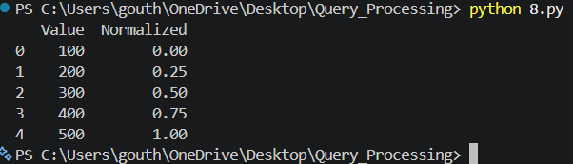

Scenario 9: Saving the Data
Problem:
Saving the cleaned data to a CSV file.
df.to_csv("cleaned_data.csv", index=False)
print ("Data saved successfully.")

OUTPUT
Data saved successfully.

Scenario 10: Automating Data Cleanup with a Script
Problem:
Creating a script to clean a dataset and apply transformations.
def clean_data(df):
df. fillna("Unknown", inplace=True)
df["Age"] = pd.to_numeric(df["Age"], errors="coerce")
return df

# Apply function
df = clean_data(df)print(df)

